WVAADC, Inc. Professional Development Summit 2022
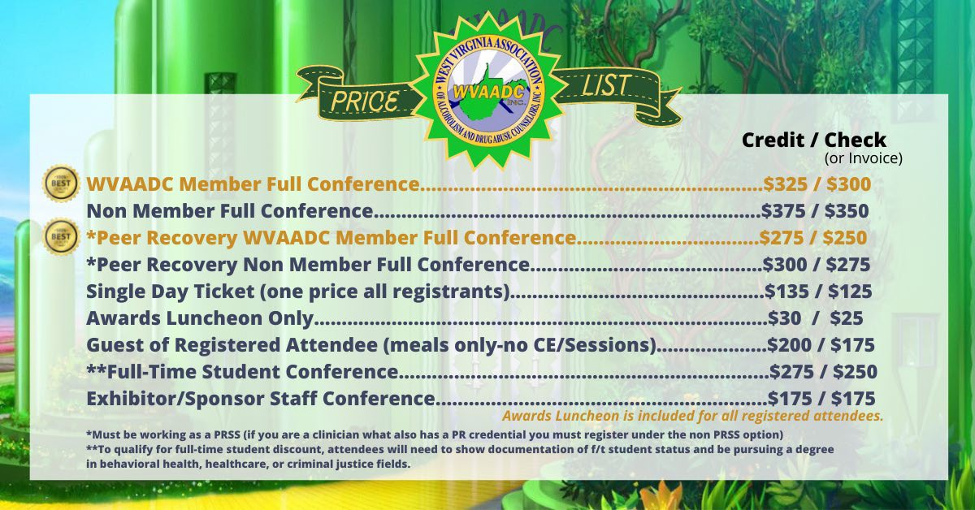
JOIN US AUGUST 30, 31, SEPTEMBER 1 in Lewisburg WV.
The registration fee is discounted for those paying by check as we don’t incur fees and want to pass a savings on to you! Members receive discounted registration- to join or renew go to https://www.naadac.org/join-or-renew

For the full conference agenda and registration information please go to our NEW refreshed website at www.wvaadc.com
To register and pay via check please fill out this form: ONE FORM PER PERSON PLEASE

Name: _ Phone Number: Email: _ Please be sure the attendee name(s) are on the check.

 | MEMBER PRICING FULL CONFERENCE (check) |  | NON MEMBER FULL CONFERENCE PRICING (check)
 | WVAADC Member- Full Conference $300 |  | Full Conference $350
 | WVAADC Member- Peer Recovery Full Conference $250 |  | Peer Recovery Full Conference $275
 | Full time student -$250
*Luncheon is included with price of full conference
LUNCHEON ONLY $25 ____
Wednesday August 31
11:45-2:00

Single Day Ticket (one price for everyone)
Tuesday 8/30 $125
Wednesday 8/31 $125 *Luncheon is included
Thursday 9/1 $125

OTHER
Exhibit/Sponsor Staff (no CEs) $175
Guests of Registered Attendees (no CEs)

If you need to register more than one person, please email Susie at wv.aadc@yahoo.com
Amount Enclosed $ Check (Payable to WVAADC, Inc.) #

All fees are non-refundable. Should the need arise due to medical or other emergencies we can convert your registration to a virtual registration. Not all sessions will be available through the virtual option.

IF PAYING BY CHECK, COMPLETE AND MAIL THE FORM WITH PAYMENT TO:
Susie Mullens / WVAADC Treasurer
1750 Woodbine Avenue
Charleston, WV 25302
Or email susielmullens@gmail.com

If you have payment questions 304-614-7177

Received by Date Deposited by WVAADC Treasurer Date

